ROCK Street Chaplains
Covid-19 Policy
(CNI)

This guidance is for all projects of ROCK Street Chaplains who may have close contact with people with potential COVID-19 or may provide immediate assistance to a person with COVID-19 until further medical assistance arrives.

As lockdown restrictions are gradually lifted our local teams may well start to work in new ways. ROCK Street Chaplains are suggesting that over the next few months (until the night-time economy opens up again) daytime patrols may be beneficial looking out for those who may be lonely (having spent several weeks isolated) or bereaved and would like to talk or receive prayer; those whose mental health has suffered because of the current situation; and helping those who are or could become vulnerable to navigate our town and city centers again.

ROCK Street Chaplains suggests that those volunteering read the following guidelines and only volunteer if they are not meant to be self-isolating or within a vulnerable category themselves. This information may need to be updated regularly.

COVID-19:
COVID-19 is an infectious disease caused by a newly discovered coronavirus. Most people infected with the COVID-19 virus will experience mild to moderate respiratory illness and recover without requiring special treatment. Older people, and those with underlying medical problems like cardiovascular disease, diabetes, chronic respiratory disease, and cancer are more likely to develop serious illness.
The best way to prevent and slow down transmission is be well informed about the COVID-19 virus, the disease it causes and how it spreads. Protect yourself and others from infection by washing your hands or using an alcohol-based hand rub frequently and not touching your face.

How COVID-19 is spread:

People can catch COVID-19 from others who have the virus. The disease spreads primarily from person to person through small droplets from the nose or mouth, which are expelled when a person with COVID-19 coughs, sneezes, or speaks so it’s important that you also practice respiratory etiquette (for example, by coughing into a flexed elbow). These droplets are relatively heavy, do not travel far and quickly sink to the ground.

These droplets can land on objects and surfaces around the person such as tables, doorknobs and handrails. People can become infected by touching these objects or surfaces, then touching their eyes, nose or mouth. This is why it is important to wash your hands regularly with soap and water or clean with alcohol-based hand rub.

People can catch COVID-19 if they breathe in these droplets from a person infected with the virus. Therefore it is important to follow government guidelines on social distancing keeping away from other people.

Who may be suspected of having COVID-19:
Anyone can catch COVID-19 and become seriously ill. However, many people with COVID-19 experience only mild symptoms. This is particularly true in the early stages of the disease. It is possible to catch COVID-19 from someone who has just a mild cough and does not feel ill. Some reports have indicated that people with no symptoms can transmit the virus. It is not yet known how often it happens.

What to do if you are required to assist someone who is symptomatic and suspected of having COVID-19:
If you do need to provide assistance to an individual wherever possible, place the person in a place away from others. If there is no separate room, ask others who are not involved in providing assistance to distance themselves away from the individual, in line with government guidelines.
Personal Protective Equipment (PPE)*:

Disposable gloves and other basic PPE are already available within teams. However, this is limited and volunteers should now bring their own PPE to meet the demands of COVID-19.

Wash your hands thoroughly with soap and water before putting on and after taking off gloves; ensure you know how to take off the gloves safely (see Appendix 1). Make sure you are wearing gloves when touching or dealing with people i.e. giving first aid or offering assistance. You must also wear gloves when disposing of bottles and glass (see litter section below).
It is advisable to have hand sanitiser available, for yourselves and possibly for those we meet on the streets (some teams already have tiny bottles ready for group leaders). Facemasks should also be worn as an extra safety measure for volunteers and plastic throw away aprons should also be considered for volunteers. Some PPE is available, although we have a limited supply
It is advised you wash your clothing as soon as you get home and other areas where that clothing has contacted.

Hand hygiene:
Wash your hands before going out on patrol and then again when you come in from patrol, including any rest breaks.
After contact with anyone wash your hands thoroughly with soap and water at the earliest opportunity. (Alcohol hand gel is recommended if soap and water is not available.)
Avoid touching your mouth, eyes or nose, unless you have recently cleaned your hands after having contact with people.
Do not shake hands with anyone or let anyone hug you (where possible).
Try and wear gloves when giving out water or other items to try and avoid skin to skin contact.
Dispose of gloves before and after each encounter with a member of the public.

Litter

Litter is a constant problem in our towns, particularly at nighttime. It can be tempting to feel the need to pick litter up and help keep streets tidy. However, we would ask Street Chaplains not to touch litter and to discard of their own litter responsibly.

As research currently suggests that the virus can live on plastic for up to three days, the health risk posed to the community outweighs our efforts to keep the community tidy. Therefore, in this vain, litter should only be touched if it poses a risk to life, such as a glass bottle lying somewhere where there is a strong chance it could be used recklessly by a drunk person. If such a bottle can be pushed out of sight by using one’s shoe, then try to do so. However, given the health hazards associated with picking litter, even outside the pandemic, it is not appropriate for Street Chaplains to pick general litter without proper equipment.

Ultimately, our ministry is to share the Good News, and care for the immediate well-being of clubbers and workers.

Coats and bags

As coats and bags are not to be taken home, please make extra effort to keep such equipment clean. Volunteers should not share the same bag during an outreach in order to avoid multiple contact with equipment inside bags.

Cleaning:
Please make sure you wipe down equipment before going out on patrol at the start of your shift and then wipe down any equipment used after coming in from patrol with antibacterial wipes or disinfectant and cloths.
Please make sure all utensils that have been used during the shift are washed thoroughly before being replaced back in the cupboards before going home and all surfaces have been wiped down with antibacterial wipes or disinfectant and cloths.
Dispose of used wipes and cloths in plastic bags that should be double bagged.

Offering assistance:
Exercise caution when offering first aid assistance at this time and only if a qualified First Aider - our role on daytime patrols is more to chat and pray and be a visible presence. If you come across someone in need of first aid then call for an ambulance (999/111) and keep others away from the person needing assistance.
If you choose to administer First Aid, remember to follow all infection/ cross contamination control measures given in your training.

If there has been a blood or body-fluid spill:
Keep people away from the area. Using the gloves provided place paper towels/roll onto the spill and seek further advice from emergency services when they arrive if they have been called. Otherwise clean the area as best as possible using cleaning aids.
Dispose of all towels/ paper bowls/ roll or cloths containing any body fluids into yellow biohazard bags.

Cardiopulmonary Resuscitation (CPR):
If you are required to perform CPR, you should conduct a risk assessment and adopt appropriate precautions for infection control.
Where possible, it is recommended that you do not perform rescue breaths or mouth-to-mouth ventilation; perform chest compressions only. Resuscitation Council (UK) Guidelines 2010 for Basic Life Support state that studies have shown that compression-only CPR may be as effective as combined ventilation and compression in the first few minutes after a cardiac arrest due to lack of oxygen.
If a decision is made to perform mouth-to-mouth a resuscitation face shield or mask should be used.

Contacts of the unwell person
If anyone has had direct contact with an individual who later tested positive for COVID-19 and makes themselves known to you, ask them to call NHS 111 and explain what has happened.

Feeling unwell:
If you feel unwell or have had any recognised symptoms or a temperature in the past 7 days please let your team leader know and do not turn up for the patrol. If you start to feel unwell go home immediately and advise the Duty Manager/Shift Team Leader.

If you have a partner or family member living with you who is in a at risk group, you should not patrol.

If you have already been given specific advice from your employer or Public Health England (PHE) about who to call if you become unwell, follow that advice.

Otherwise, if you develop high temperature, fever, cough or difficulty breathing within 14 days of assisting someone unwell and at risk of COVID-19, call NHS 111 (or 999 if it is a medical emergency) and explain that you recently provided assistance to someone with the virus.

This is offered as guidance only and should be modified and agreed locally as different situations will require different guidance. It may be worth speaking to local Police/NHS /Public Health Department/Local Authority contacts as you make plans to start patrolling again. Government guidelines are changing regularly and patrols (day or night) should not be started until the Government of the country where you operate introduces a relaxation of rules in terms of town and city centres.

Appendix 1: How to Safely Remove Gloves

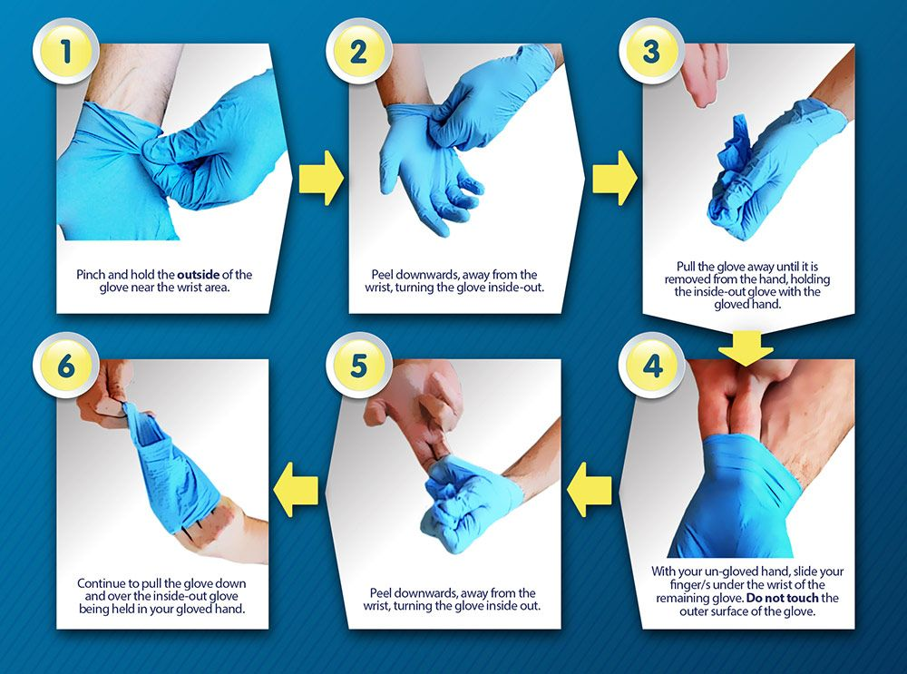
References and Further Information:
https://www.nhs.uk/conditions/coronavirus-covid-19/
https://www.gov.uk/coronavirus
https://www.who.int/health-topics/coronavirus#tab=tab_1
https://www.gov.uk/government/publications/covid-19-guidance-on-services-for-people-experiencing-rough-sleeping

